**FDO Demersal shallow omnivore??? they’re carnivores**: Blue grenadier, Red emperor, snappers, Tailor also in FDC (shallow carnivore, King George whiting, Western blue groper, Baldchin grouper, Breaksea cod, foxfish *Bodianus frenchii* (Labridae)

**Baldchin groper** (Choerodon rubescens): sea urchins, gastropods = carnivore

**Juveniles** diet composition changed with growth from small crustaceans to various organisms such as large crustaceans, gastropods, bivalves and so on and were diversified

# Breaksea cod (Epinephelides armatus) omnivore

# 

# <99mm 100-199 200-299 300-399 400-499 500-599

# 

*E. armatus* ingests labrids and tripterygiids. The volumetric contributions of decapods to the diets of *E. armatus* declined precipitously from 67% in fish *<*100 mm to 33% in those of 100–199 mm and to *<*5% in those *>*300 mm, whereas those of teleosts increased progressively from

33% in the smallest fish to 67% in fish of 100–199 mm and then to 100% in the largest fish. The main teleost prey of *G. hebraicum* and *E. armatus* comprised pempherids, a family of small species that is abundant over reefs in Australia,

**Red Emperor (*Lutjanus sebae​* )** Overall, the main prey items were fishes, shrimps and crabs

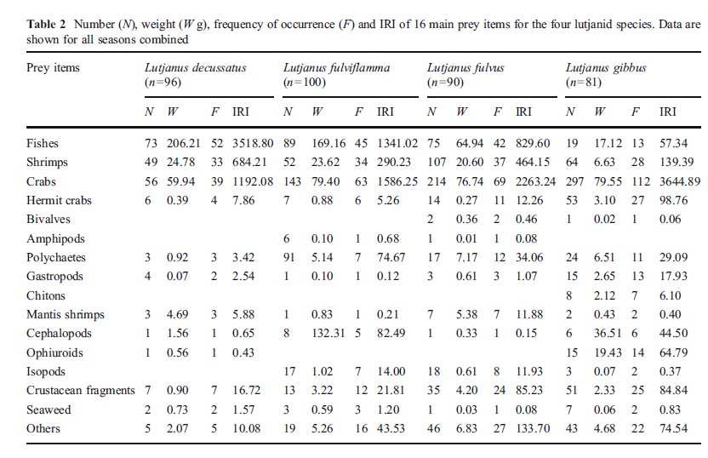

**Whiting, King George carnivore** Sillaginodes punctata Prey items were dominated by benthic harpacticoid copepods, gammaridian amphipods, and at the Calhoun, Grassy Point, and Edwards Point sites, planktonic Crustacea. There was a decreasing proportion of plankton in the diet with increasing post-transition age.

*S. bassensis* consumes mainly amphipods, whereas the smaller representatives of *S. vittata, S.* *burrus, S. schomburgkii and Sillaginodes* punctata ingest large volumes of copepods, which are typically abundant in protected nearshore waters. Crustaceans and polychaetes were the taxa most frequently ingested by each of the five *Sillago* species and by *Sillaginodes unctata*, and they also made the greatest contributions to the volume of the gut contents of these species. However, while molluscs were ingested by the five *Sillago* species, they were absent from the guts of *Sillaginodes punctata*. Similarly, echinoderms were often present in the guts of *Sillago bassensis, S. vittata, S. burrus and S. robusta*, but were rarely or never observed in those of *S. schomburgkii and Sillaginodes punctata*. Amphipods were by far the most frequently-consumed crustacean taxa and made the greatest contributions to the gut contents of all whiting species, except *Sillago burrus*. While amphipods also made a large contribution to the diet of *S. burrus*, the contribution of copepods was greater. Copepods were also often ingested by *S. vittata and Sillaginodes punctata*. Although tanaids were frequently consumed

by *Sillago bassensis, S. burrus, S. robusta and Sillaginodes punctata*, they constituted only a small volume of the stomach contents of these four species. *Sillago robusta* was the only whiting species that ingested the small penaeid *Lucifer* sp., and carids were far more frequently consumed by *Sillaginodes punctata* than by any other species. The prevalence and volume of errant polychaetes in stomachs were both greater than those of sedentary

polychaetes in the case of five of the six whiting species, and bivalves were the most important molluscan taxa consumed by each whiting species. Ophiuroids was the most important of the two categories of echinoderms ingested by *Sillago bassensis, S. vittata,*

*S. burrus and S. robusta*. Echinoids made a far greater contribution to the diet of *S. bassensis* than to that of the last three of these species. In nearshore waters, the diet of the smallest representatives of *Sillago bassensis*, i.e. 25 to 74 mm in length, consisted almost exclusively of amphipods, whereas that of the same length class of *S. vittata and Sillaginodes punctata* comprised predominantly copepods, and the diet of *Sillago burrus* was almost entirely a combination of copepods and errant polychaetes. The larger members of *S. bassensis* found in nearshore waters, i.e. those of 75 to 124 mm in length, continued to ingest large volumes of amphipods. The contributions made by copepods to the diet of both *S. vittata* and *Sillaginodes punctata*, declined sharply from >50% in fish of 25 to 74 mm, to <20% in the 75 to 124 mm length class, whereas the proportions of amphipods and also of errant polychaetes, in the case of *S. punctata*, rose during the corresponding increase in size. Carid shrimps were ingested only by *S. punctata* >175 mm in length, in which they comprised >15% of the volume of the gut contents, and crabs were found in large volumes only in the largest members of this species. The diets of particularly the larger species of whiting change markedly with increasing body size. This progressive ontogenetic change involves a reduction in the consumption of small epibenthic crustaceans and an increase in the ingestion of larger prey such as polychaetes, bivalves, ophiuroids and crabs, which live in or on the substrate.

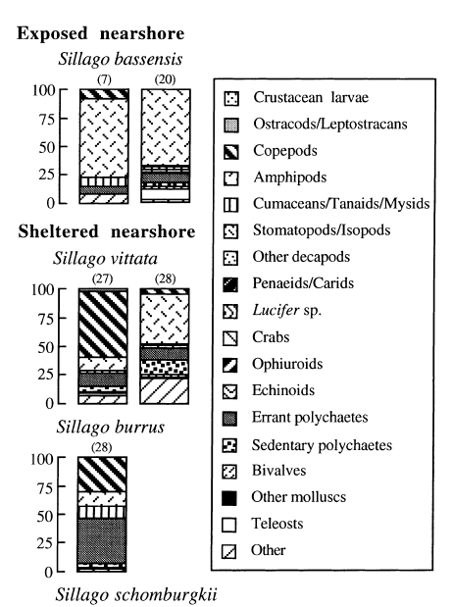

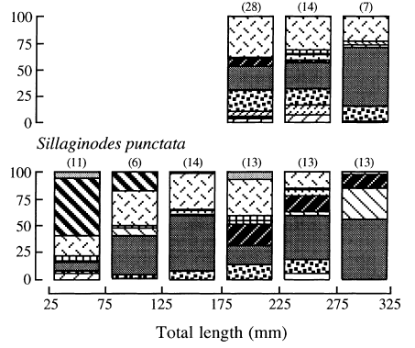

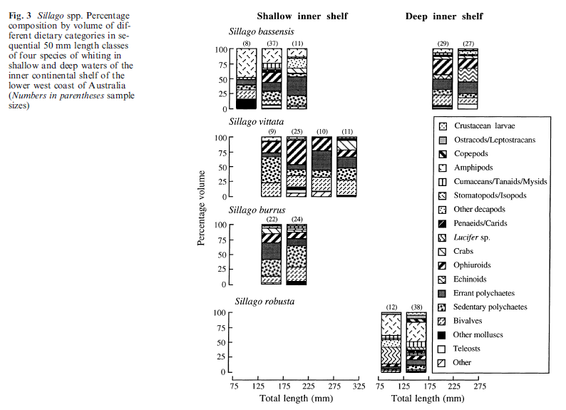

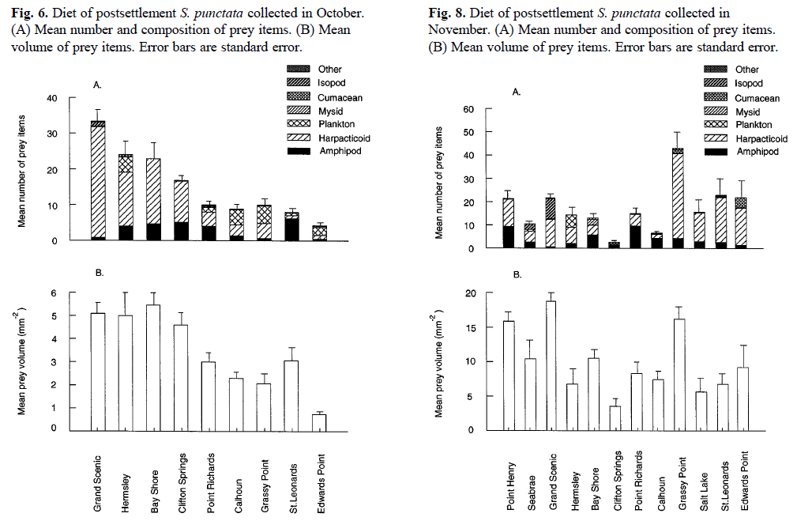

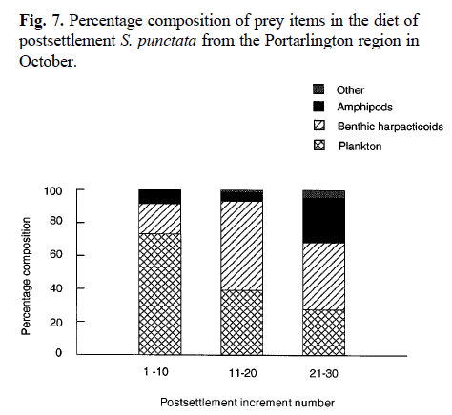

**Western blue groper carnivore** *Achoerodus gouldii* wrasse (Labrinae)

Small fish foraged mainly by taking feeding bites in algal canopies, or small mussels from bare rock. With increasing size, fish switched to more efficient suction-bite feeding in which epifaunal aggregates were slicked into the mouth, and foraged increasingly on epifaunal aggregates within algal mats. Small and medium-sized fish tended to select foraging habitats with the highest densities of epifauna, whereas large fish, with an expanded home range, captured large prey as well as algal epifauna.

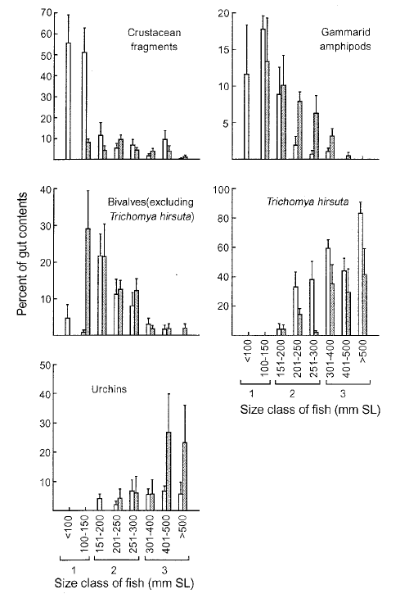

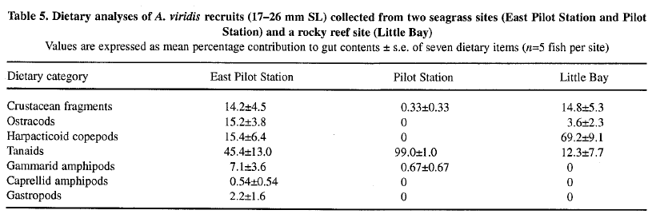

Shepherd, S. S. and Brook, J. B. (2005). Foraging ecology of the western blue groper,

*Achoerodus gouldii*, at Althorpe Islands, South Australia. *Transactions of the Royal*

*Society of South Australia* **129**: 202-208.

Shepherd, S. S. and Brook, J. B. (2005). Foraging ecology of the western blue groper,

*Achoerodus gouldii*, at Althorpe Islands, South Australia. *Transactions of the Royal*

*Society of South Australia* **129**: 202-208.

**Blue Grenadier**, carnivore Macruronus novaezelandiae The Blue Grenadier is a benthic species that is found inshore as juveniles and in continental slope waters at depths from 450 m to 800 m as adults. Occur at depths of 10_900 m, but are most abundant at 200-600 m, where they are often the most abundant species caught in demersal trawls Prey was predominantly euphausiids, mesopelagic fishes and natant decapods. Frequency of occurrence: Amphipods 11%, Pasiphaeidae 24.2%, Sergestidae 16.3%, Euphausiacea 36.1%, Macrouridae 5.5%, Myctophidae 52.1%, Sternoptychida 7.8%, Teuthoidea 5.3%, Salpidae 3.2%. The diet of hoki was characterised by euphausiids, mesopelagic and benthopelagic fishes, and natant decapods. Euphausiids occurred in 36% of the stomachs, were the only prey found in high numbers (_50 individuals) in a single stomach, but contributed little prey weight (1%). Myctophids were found in 52% of the stomachs, contributed 20% of the prey weight and consisted of at least 10 genera, although the majority could not be identified to species. Macrourid fishes were relatively infrequent but contributed the greatest prey. weight (33%), with the benthopelagic species Coelorinchus oliverianus and Lepidorhynchus denticulatus most important. The mesopelagic fish Photichthys argenteus was also important by prey weight (17%). The most important families of natant decapod prey were Pasiphaeidae,

Sergestidae and Oplophoridae, together contributing 9% of the prey weight. As hoki increased in length, Pasiphaeidae, Sergestidae, Photichthyidae and Macrouridae increased in importance, and Euphausiacea and Sternoptychidae decreased in importance. Macrouridae appeared in the diet rather abruptly once hoki exceeded 84.0 cm TL. Euphausiacea, Myctophidae and Sternoptychidae were most important in the diet of small to intermediate-sized hoki (46.7-83.8 cm TL), and Pasiphaeidae, Sergestidae, Myctophidae and Macrouridae were most important in the larger hoki (84.0_112.0 cm TL). Myctophidae had the greatest importance in the diet of intermediate-sized hoki, peaking at 60.3_66.9 cm TL. Other fishes and cephalopods increased in importance with increasing hoki size, from on average 0.1% of prey weight at B46.7 cm TL to 12% of prey weight at 92.0-112.0 cm TL.

The food consists almost entirely of mesopelagic fauna. The major prey are myctophid fish ***Lampanyctodes hectoris,*** other fishes, natant decapods, euphausiids and squid.

***Adult fish*** *(30-120 cm SL; 400-5400 g)*

The diet consisted predominantly of mesopelagic fish (Table ***2);*** the myctophid

*Lampanyctodes hectoris* was the most common prey and the chief contributor to the energy

intake, with most of the remainder coming from *Lepidorhynchus denticulatus, Maurolicus*

*muelleri, Diaphus danae* and juvenile *Macruronus novaezelandiae.* Juvenile *M. novaezelandiae,* which first appeared in adult stomachs in December 1984, made up 20% of energy intake by April 1985. Crustacea contributed little to the total energy intake. Euphausiids were the most frequently consumed, with *Euphausia sirnilis* var, *armata* the only identifiable species. *Pasiphae* sp. and *Oplophorus* spp., the major carids identified, accounted for one-third of the carid total (Table ***2).***Squid occurred frequently in catches in April, contributing one-fifth of that month's energy intake (Table 2). One occurrence in October 1984 accounted for 10% of the energy for that month, but, overall, squid occurred in the diet of about 5% of the fish and contributed only a minor part of energy intake.

***Juvenile fish (15-29 cm SL; 37-65 g)***

***Lampanyctodes hectoris*** occurred in about one-third of stomachs of juveniles caught

from December to April, but contributed nearly two-thirds of the energy (Table 3).

Euphausiids had a high frequency of occurrence (79.8%) but, as in adult fish, accounted

for less of the energy (25%). The incidence of euphausiids in the diet increased over the

3 months (December, February and April) in which juveniles were sampled, while that of

L. ***hectoris*** decreased.

***Bass Strait***

The diet of adult ***M. novaezelandiae*** from Bass Strait varied considerably. It consisted

chiefly of fish, with ***Lampanyctodes hectoris*** the most frequent prey species, although its

frequency of occurrence varied bimonthly (Table 4). Other fish species were consumed

irregularly: ***Lepidorhynchus denticulatus, Lepidopus caudatus*** and juvenile ***M. novaezelandiae*** contributed about 65% of energy intake in December 1984, though they occurred at relatively low frequency, whereas ***Apogonops anomalus*** accounted for over 70% of the energy intake in June 1984 but occurred in only 15% of stomachs. Unidentifiable fish formed a high proportion of the diet. Crustacea, particularly the carids ***Plesionika martia, Pasiphae*** sp., ***Oplophorus spinosus*** and ***Haliporoides*** sp., were consumed frequently but contributed little to energy intake (Table 4). In February 1985, Crustacea occurred in 75% of stomachs, but accounted for less than 10% of energy. Squid were found in 6% of stomachs (Table 4). Species identified included ***Lycoteuthis diadema, Iridioteuthis*** sp., ***Octopoteuthis*** sp., ***Nototodarus gouldi*** and ***Todarodes fillipovae.*** Diets of west coast adult fish we're similar to those of fish from Bass Strait and Maria Island. ***Lampanyctodes hectoris*** was an important prey item. Crustacea again contributed relatively little to total energy consumed, although euphausiids occurred at an average frequency of 8.5%. The penaeid ***Aristeomorpha foliacea*** occurred in only 1 month but at a frequency of 6.5%. Squid were present in 35.7% of fish in June 1984, constituting 53% of the energy for that month. The occurrence of squid declined thereafter; they were absent altogether from December 1984 and April 1985 samples. Overall, their frequency of occurrence was only 6.3% and their energy contribution 7.1 %.

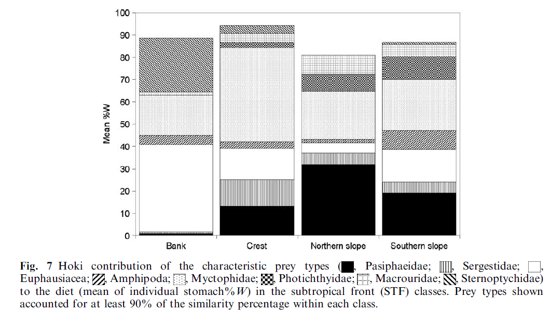

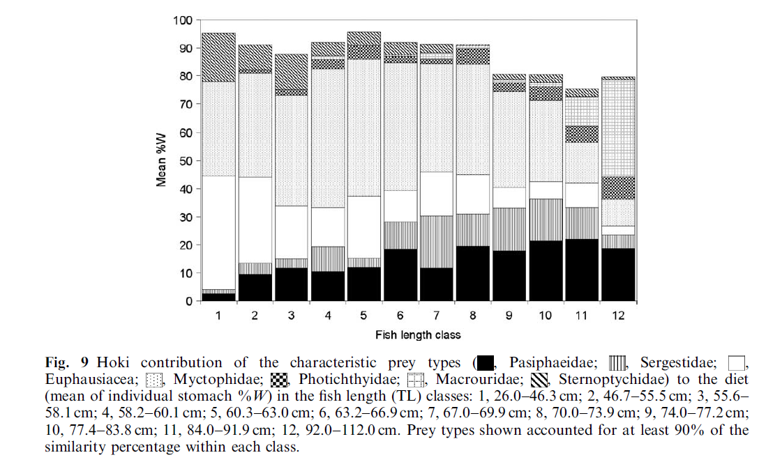

**snappers Snapper *Pagrus auratus*** The natural diet of snapper includes crabs, sea urchins, scallops, clams and mussels. Echinoderms, teleosts, crustaceans and molluscs made the greatest overall contributions to the diet of Pagrus auratus on the basis of both their frequency of occurrence in the gut contents and their volumetric contributions to those contents. While ophiuroids (belonging entirely to the family Ophiuridae) and echinoids were the two major echinoderm classes in the gut contents of Pagrus auratus, the former was ingested far more frequently and made a far greater contribution to those of smaller

fish (<400 mm) from the lower west coast than to those of large fish from both this region and the mid west coast. The decapod component of the diet of P. auratus was always overwhelmingly dominated by crabs, which represented a number of different families, such as the Portunidae and the Majidae. With the two most important dietary groups of molluscs

consumed by Pagrus auratus on the lower west coast, gastropods tended to be ingested slightly more frequently and in greater volumes by larger fish (i.e. >400 mm), whereas the reverse was the case with bivalves. While polyplacophorans and cephalopods made a small but appreciable contribution to the diets of larger P. auratus from the lower west coast, these two groups were either absent or present in only small volumes in the gut contents of both small P. auratus from the lower west coast and larger individuals from the mid west coast. On the mid west coast, where smaller Pagrus auratus could not be obtained, echinoids and teleosts were by far the most important contributors to the diets of this species and collectively contributed far more to those diets than to those of the corresponding size

range of fish on the lower west coast. On the lower west coast, an increase in the body size of P. auratus was accompanied by a dramatic decline in the dietary contribution made by ophiuroids, from as high as ca 63% in the smallest fish, and an increase in that of teleosts, with asteroids becoming ingested by the larger individuals and contributing as much as 25% to the diets of the largest P. auratus. The dietary contributions of echinoids and gastropods tended initially to increase with body size and then decline in the larger individuals. These size-related changes were largely driven by a very pronounced and progressive shift in the size and type of prey from small ophiuroid echinoderms (brittle stars) by the smallest individuals to substantial consumptions of brachyuran crabs, teleosts and echinoid echinoderms (sea urchins) and ultimately also asteroid echinoderms (starfish) by the largest individuals. The ingestion of very large amounts of small and slow-moving ophiuroids by small P. auratus contrasts with the situation elsewhere, with these echinoderms never being found in the gut contents of such P. auratus in a gulf in South Australia (Saunders

et al., 2012) and only occasionally in a gulf and estuary in New Zealand (Colman, 1972; Usmar, 2012). However, this shift from the consumption of such large volumes of ophiuroid echinoderms by the smallest fish to other prey by larger and older fish almost certainly reflects, in part, a change from foraging over soft sediments to areas over and around reefs. The view that small snapper feed over soft substrata is entirely consistent with the results of

studies of the 0þ of this species in a large marine embayment in South Australia As potential alternative prey for small P. auratus, e.g. polychaetes and amphipods, are relatively abundant

in Cockburn Sound (Oceanica, 2007), it is proposed that brittle stars are targeted by small snapper in Cockburn Sound, because those echinoderms would be particularly visible in the turbid waters of this embayment. On the lower west coast of Australia, the increased ingestion of teleosts and crabs by Pagrus auratus, as this predator increases in size was see. The stomach contents of medium-sized P. auratus, i.e. 300e599 mm TL, on the lower west coast of Australia contained substantial volumes of sea urchins. As large starfish, such as Astropecten preissei, were only ingested by the larger fish on the lower western Australian coast, i.e. >600 mm TL. The ingestion of substantial volumes of both starfish and sea urchins by P. auratus on the lower west coast of Australia is atypical for a sparid.

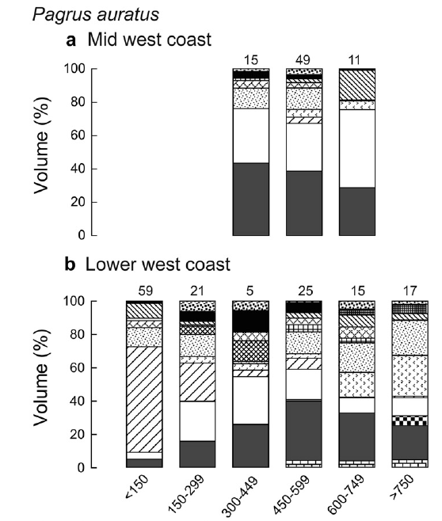 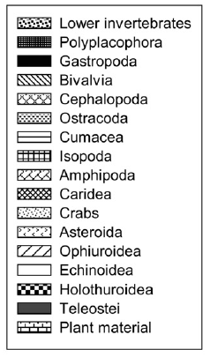

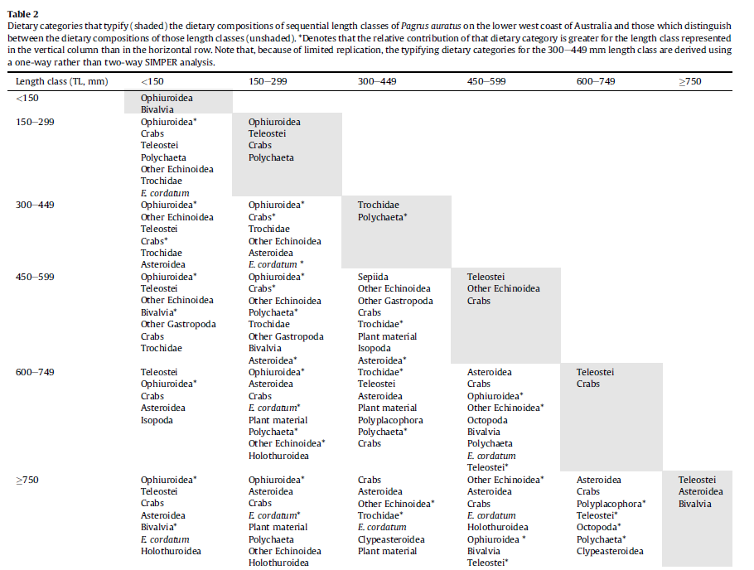

**foxfish *Bodianus frenchii*** omnivore consumed large volumes of gastropod molluscs

(19·5%), decapod crustaceans (21·2%) and echinoderms (18·8%), and lesser but

still substantial volumes (4–7%) of each of polyplacophoran and bivalve molluscs, The most frequently ingested of these categories, by far, were gastropods, decapods and echinoderms, which were found in the guts of *c.* 50, 52 and 31%, respectively, of all *B. frenchii* examined. trochid gastropods and ophiuroid echinoderms contributed more than three times to the dietary volume of *B. frenchii* on the south than west coasts. Although crustaceans (almost exclusively decapods) and teleosts also dominated the diet of *E. armatus*, the volumetric contribution made by teleosts to the diet of this species was far greater, *i.e. c.* 81 *v.* 44%, paralleling the situation with their frequency of occurrence in stomach samples. The Pempherididae was the most important of the numerous identifiable teleost families ingested by both *G. hebraicum* and *E. armatus*. As the body size of *B. frenchii* increased on the west coast, the volumetric contributions of gastropods and small crustaceans declined, whereas that of echinoderms rose and that of decapods remained similar and polyplacophoran and bivalve molluscs only became ingested by individuals when they had reached 200 mm *L*T. Furthermore, in the case of gastropods, the smaller individuals of *B. frenchii* ingested

far greater volumes of ceriithids and scalids, which are relatively small and thinshelled,

than their larger individuals, whereas the reverse trend was exhibited by trochids and turbinids, which are typically larger and more robust. The volumetric contributions of decapods to the diets of *E. armatus* declined precipitously from 67% in fish *<*100 mm to 33% in those of 100–199 mm and to *<*5% in those *>*300 mm, whereas those of teleosts increased progressively from 33% in the smallest fish to 67% in fish of 100–199 mm and then to 100% in the largest fish [Fig. 2(c)].

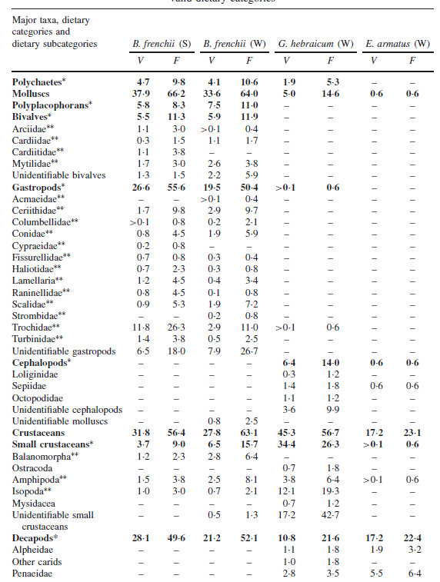

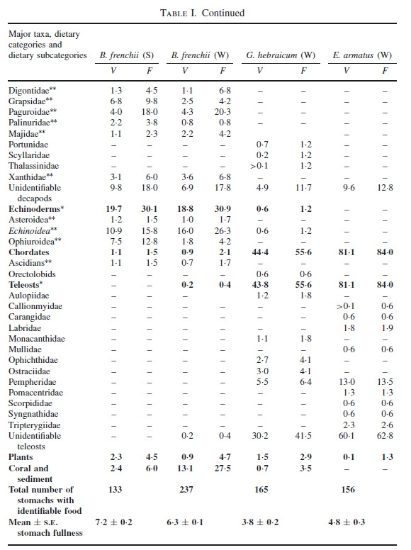

# polychaetes and small crustaceans

# 

# <99mm 100-199 200-299 300-399 400-499

# 

The greatest overall difference between the dietary compositions of the three species on the lower west coast of Australia resides in the fact that, although teleosts had been ingested by only one of the 237 individuals of *B. frenchii* from that coast, large amounts of teleosts were consumed by *G. hebraicum*, and even more particularly by *E. armatus.* In contrast, molluscs and echinoderms, which were the most important components of the diet of *B. frenchii,* were consumed in only moderate or small amounts by *G. hebraicum* and essentially never by *E. armatus*. Furthermore, the mollusc component of the diet of *B. frenchii* consisted mainly of

bivalves and gastropods and never cephalopods, whereas the last taxon was essentially

the only mollusc group represented in the diet of *G. hebraicum*. Crustaceans made an important contribution to the diet of each of the three species, with decapods prominent in the diets of all three species and small crustaceans well represented in the diet of *B. frenchii* and especially of *G. hebraicum* but not of *E. armatus*. *B. frenchii* ingested a range of the essentially sedentary taxa that are frequently found attached to or lodged in reefs, *e.g.* trochids and other gastropods and echinoderms, broadly paralleling the situation recorded for the confamilial *Notolabrus tetricus* (Richardson) by Shepherd & Clarkson (2001). While *G. hebraicum* and *E. armatus* both targeted free-swimming organisms, such as teleosts, this was particularly true for the latter species and is also the case for some other serranids (Connell, 1998; St John, 1999; Beukers-Stewart & Jones, 2004). The main teleost prey of *G. hebraicum* and *E. armatus* comprised pempherids, a family of small species that is abundant over reefs in Australia (Annese & Kingsford, 2005).

# 

The trends exhibited by the volumetric contributions of the various dietary components

of the sequential length classes of *B. frenchii* and *E. armatus* show that the types of food ingested by both these species undergo size-related changes (Fig. 2), a feature emphasized by the sequential progression of the points for those dietary samples on the ordination plot shown in Fig. 3. In the case of *B. frenchii*, these changes involved a gradual shift from crustaceans and gastropods to echinoderms (mainly echinoids) and polyplacophoran and bivalve molluscs, which is similar to the trend exhibited by another large labrid, the eastern blue groper *Achoerodus viridis* (Steindachner) in south-eastern Australia (Gillanders, 1995). In contrast, those of *E. armatus* largely reflected a marked shift from decapods early in life to an increasing domination by teleosts after individuals had reached only 100 mm, which

broadly parallels the situation for the large coral reef serranid *Plectropomus leopardus*

(Lacepede) in eastern Australia (St John, 1999).

**Breaksea cod omnivore** <99mm

|  |  |
| --- | --- |
| **prey item** | **probability of consuming** |
| plant | 0.1 |
| echinoderm | 0.3 |

**Breaksea cod** 100-199 mm

|  |  |
| --- | --- |
| **prey item** | **probability of consuming** |
| plant | 0.3 |
| echinoderm | 0.1 |

**Breaksea cod** 200-299 mm

|  |  |
| --- | --- |
| **prey item** | **probability of consuming** |
| MA plant | 0.3 |
| BG echinoderm | 0.15 |
| LOB decapod | 0.1 |
| LOJ decapod | 0.1 |
| MAZ decapod | 0.1 |

**Breaksea cod** 300-399 mm

|  |  |
| --- | --- |
| **prey item** | **probability of consuming** |
| MA plant | 0.3 |
| BG echinoderm | 0.015 |
| LOB decapod | 0.1 |
| LOJ decapod | 0.1 |
| MAZ decapod | 0.1 |

**Breaksea cod** 400-499 mm

|  |  |
| --- | --- |
| **prey item** | **probability of consuming** |
| plant | 0.3 |
| echinoderm | 0.001 |
| LOB decapod | 0.1 |
| LOJ decapod | 0.1 |
| MAZ decapod | 0.1 |

**Breaksea cod** 500-599 mm

|  |  |
| --- | --- |
| **prey item** | **probability of consuming** |
| plant | 0.3 |
| echinoderm | 0.001 |
| LOB decapod | 0.1 |
| LOJ decapod | 0.1 |
| MAZ decapod | 0.1 |

**Breaksea cod** 600+ mm

|  |  |
| --- | --- |
| **prey item** | **probability of consuming** |
| FSR wrasses | 0.3 |
| FDT blennies | 0.3 |

**Red Emperor**

|  |  |
| --- | --- |
| FSR wrasses | 0.2 |
| FDT blennies | 0.2 |
| LOJ decapod | 0.1 |
| MAZ decapod | 0.1 |
| PRW shrimps | 0.2 |
| BD ophiuroids | 0.05 |
| CEP cephalopods | 0.05 |
| BG amphipods, isopods, gastropods | 0.05 |
| BC polychaetes | 0.05 |
| MA Macrooalgae | 0.05 |
| BFF bivalves | 0.1 |

# Blue Grenadier carnivore,

# size 1

|  |  |
| --- | --- |
| **prey item** | **probability of consuming** |
| ZKL Euphausids | 0.3 |
| FMP Myctophids | 0.3 |
| PRW shrimps | 0.03 |
| BG | 0.01 |

# Size 2

|  |  |
| --- | --- |
| **prey item** | **probability of consuming** |
| ZKL Euphausids | 0.2 |
| FMP Myctophids | 0.3 |
| PRW shrimps | 0.05 |

# Size 3

|  |  |
| --- | --- |
| **prey item** | **probability of consuming** |
| ZKL Euphausids | 0.1 |
| FMP Myctophids | 0.3 |
| PRW shrimps | 0.07 |

# Size 4

|  |  |
| --- | --- |
| **prey item** | **probability of consuming** |
| ZKL Euphausids | 0.1 |
| FMP Myctophids | 0.3 |
| PRW shrimps | 0.08 |
|  |  |

# Size 5

|  |  |
| --- | --- |
| **prey item** | **probability of consuming** |
| ZKL Euphausids | 0.08 |
| FMP Myctophids | 0.3 |
| PRW shrimps | 0.08 |

# Size 6

|  |  |
| --- | --- |
| **prey item** | **probability of consuming** |
| ZKL Euphausids | 0.08 |
| FMP Myctophids | 0.3 |
| PRW shrimps | 0.09 |

# Size 7

|  |  |
| --- | --- |
| **prey item** | **probability of consuming** |
| ZKL Euphausids | 0.07 |
| FMP Myctophids | 0.3 |
| PRW shrimps | 0.1 |
| FDO | 0.001 |

# Size 8

|  |  |
| --- | --- |
| **prey item** | **probability of consuming** |
| ZKL Euphausids | 0.07 |
| FMP Myctophids | 0.3 |
| PRW shrimps | 0.1 |
| FDO | 0.001 |

# Size 9

|  |  |
| --- | --- |
| **prey item** | **probability of consuming** |
| ZKL Euphausids | 0.06 |
| FMP Myctophids | 0.3 |
| PRW shrimps | 0.1 |
| FDO | 0.07 |

# Size 10

|  |  |
| --- | --- |
| **prey item** | **probability of consuming** |
| ZKL Euphausids | 0.06 |
| FMP Myctophids | 0.3 |
| PRW shrimps | 0.001 |
| FDO | 0.07 |
| FDO | 0.2 |
| FPP | 0.05 |

# foxfish *Bodianus frenchii* omnivore

# <100 mm

|  |  |
| --- | --- |
| **prey item** | **probability of consuming** |
| MAZ | 0.3 |
| BG | 0.1 |
| FSR | 0.1 |
| COR | 0.01 |
| MA | 0.01 |
| DL | 0.01 |
| BAC | 0.01 |
| DR | 0.01 |

# <100 – 199 mm

|  |  |
| --- | --- |
| **prey item** | **probability of consuming** |
| MAZ | 0.1 |
| BG | 0.1 |
| FSR | 0.2 |

# >300 mm

|  |  |
| --- | --- |
| **prey item** | **probability of consuming** |
| MAZ | 0.1 |
| BG | 0.1 |
| FSR | 0.3 |

**Breaksea cod omnivore** <99mm **1**

|  |  |
| --- | --- |
| **prey item** | **probability of consuming** |
| plant | 0.1 |
| echinoderm | 0.3 |

# foxfish *Bodianus frenchii* omnivore <100 mm

|  |  |
| --- | --- |
| **prey item** | **probability of consuming** |
| MAZ | 0.3 |
| BG | 0.1 |
| FSR | 0.1 |
| COR | 0.01 |
| MA | 0.01 |
| DL | 0.01 |
| BAC | 0.01 |
| DR | 0.01 |

**summary 1**

|  |  |
| --- | --- |
| **prey item** | **probability of consuming** |
| MAZ | 0.3 |
| BG | 0.1 0.3 |
| FSR | 0.1 |
| COR | 0.01 |
| MA | 0.01 0.1 |
| DL | 0.01 |
| BAC | 0.01 |
| DR | 0.01 |

**Breaksea cod** 100-199 mm **2**

|  |  |
| --- | --- |
| **prey item** | **probability of consuming** |
| plant | 0.3 |
| echinoderm | 0.1 |

# foxfish *Bodianus frenchii* omnivore >100 – 199 mm

|  |  |
| --- | --- |
| **prey item** | **probability of consuming** |
| MAZ | 0.1 |
| BG | 0.1 |
| FSR | 0.2 |

**summary 2**

|  |  |
| --- | --- |
| **prey item** | **probability of consuming** |
| MAZ | 0.1 |
| BG | 0.1 0.1 |
| FSR | 0.2 |
| MA plant | 0.3 |

**Breaksea cod** 200-299 mm 2 **3**

|  |  |
| --- | --- |
| **prey item** | **probability of consuming** |
| MA plant | 0.3 |
| BG echinoderm | 0.15 |
| LOB decapod | 0.1 |
| LOJ decapod | 0.1 |
| MAZ decapod | 0.1 |

**Breaksea cod** 300-399 mm 4

|  |  |
| --- | --- |
| **prey item** | **probability of consuming** |
| MA plant | 0.3 |
| BG echinoderm | 0.015 |
| LOB decapod | 0.1 |
| LOJ decapod | 0.1 |
| MAZ decapod | 0.1 |

# foxfish *Bodianus frenchii* omnivore >300 mm

|  |  |
| --- | --- |
| **prey item** | **probability of consuming** |
| MAZ | 0.1 |
| BG | 0.1 |
| FSR | 0.3 |

**summary 4**

|  |  |
| --- | --- |
| **prey item** | **probability of consuming** |
| MA plant | 0.3 |
| BG echinoderm | 0.015 0.1 |
| LOB decapod | 0.1 |
| LOJ decapod | 0.1 |
| MAZ decapod | 0.1 0.1 |
| FSR | 0.3 |

**Breaksea cod** 400-499 mm **5**

|  |  |
| --- | --- |
| **prey item** | **probability of consuming** |
| MA plant | 0.3 |
| BG echinoderm | 0.001 |
| LOB decapod | 0.1 |
| LOJ decapod | 0.1 |
| MAZ decapod | 0.1 |

**Breaksea cod** 500-599 mm **6-7**

|  |  |
| --- | --- |
| **prey item** | **probability of consuming** |
| MA plant | 0.3 |
| echinoderm | 0.001 |
| LOB decapod | 0.1 |
| LOJ decapod | 0.1 |
| MAZ decapod | 0.1 |

**Breaksea cod** 600+ mm 6 **8-10**

|  |  |
| --- | --- |
| **prey item** | **probability of consuming** |
| FSR wrasses | 0.3 |
| FDT blennies | 0.3 |

# Reference:

# <http://www.pir.sa.gov.au/fisheries/recreational_fishing/target_species/snapper>

Johansson, C. L.; Bellwood, D. R.; Depczynski, M.; et al. 2013

[The distribution of the sea urchin Echinometra mathaei (de Blainville) and its predators on Ningaloo Reef, Western Australia: The implications for top-down control in an intact reef system. Journal of Experimental Marine Biology and Ecology  Volume: 442   Pages: 39-46](http://apps.webofknowledge.com/full_record.do?product=UA&search_mode=GeneralSearch&qid=18&SID=X2UT1jczAgkzwJYDfL5&page=1&doc=1)

# Microhabitat refuges and risk of predation for species of trochid gastropod (Trochus histrio and Tectus pyramis) at the Houtman Abrolhos, Western Australia. [Scheibling, Robert E.](http://apps.webofknowledge.com/OneClickSearch.do?product=UA&search_mode=OneClickSearch&colName=ZOOREC&SID=X2UT1jczAgkzwJYDfL5&field=AU&value=Scheibling,%20Robert%20E.&ut=ZOOREC:ZOOR13500020159&pos=1&excludeEventConfig=ExcludeIfFromFullRecPage); [Hatcher, Bruce G.](http://apps.webofknowledge.com/OneClickSearch.do?product=UA&search_mode=OneClickSearch&colName=ZOOREC&SID=X2UT1jczAgkzwJYDfL5&field=AU&value=Hatcher,%20Bruce%20G.&ut=ZOOREC:ZOOR13500020159&pos=2&excludeEventConfig=ExcludeIfFromFullRecPage) **Editor(s):** [Wells, Fred E.](http://apps.webofknowledge.com/OneClickSearch.do?product=UA&search_mode=OneClickSearch&excludeEventConfig=ExcludeIfFromFullRecPage&colName=ZOOREC&SID=X2UT1jczAgkzwJYDfL5&field=ED&value=Wells,%20Fred%20E.) Proceedings of the Seventh International Marine Biological Workshop: the marine flora and fauna of the Houtman Abrolhos Islands, Western Australia. Held at Beacon Island, Houtman Abrolhos Islands, Western Australia, in May 1994. Volume 1.  **Pages:** 159-176  **Published:** 1997

# [Platell ME](http://www.ncbi.nlm.nih.gov/pubmed?term=Platell%20ME%5BAuthor%5D&cauthor=true&cauthor_uid=20537013), [Hesp SA](http://www.ncbi.nlm.nih.gov/pubmed?term=Hesp%20SA%5BAuthor%5D&cauthor=true&cauthor_uid=20537013), [Cossington SM](http://www.ncbi.nlm.nih.gov/pubmed?term=Cossington%20SM%5BAuthor%5D&cauthor=true&cauthor_uid=20537013), [Lek E](http://www.ncbi.nlm.nih.gov/pubmed?term=Lek%20E%5BAuthor%5D&cauthor=true&cauthor_uid=20537013), [Moore SE](http://www.ncbi.nlm.nih.gov/pubmed?term=Moore%20SE%5BAuthor%5D&cauthor=true&cauthor_uid=20537013), [Potter IC](http://www.ncbi.nlm.nih.gov/pubmed?term=Potter%20IC%5BAuthor%5D&cauthor=true&cauthor_uid=20537013).2010. Influence of selected factors on the dietary compositions of three targeted and co-occurring temperate species of reef fishes: implications for food partitioning. [J Fish Biol.](http://www.ncbi.nlm.nih.gov/pubmed/20537013) 76(6):1255-76

Kanashiro, K 1998 . Morphology, and changes of distribution and food habits with growth, of late larvae and juveniles of black-spot tuskfish, *Choerodon schoenleinii* (Labridae), settled on seagrass beds of Okinawa Island, the Ryukyus. Nippon Suisan Gakkaishi,64 (3), 427-434

Atsushi Nanami & Tamaki Shimose. 2013. Interspecific differences in prey items in relation to morphological characteristics among four lutjanid species (*Lutjanus decussatus, L.*

*fulviflamma, L. fulvus and L. gibbus*). Environ Biol Fish (2013) 96:591–602

G.P. Jenkins,1 M.J. Wheatley, and A.G.B. Poore. 1996. Spatial variation in recruitment, growth, and feeding of postsettlement King George whiting, *Sillaginodes punctata*, associated with seagrass beds of Port Phillip Bay, Australia Can. J. Fish. Aquat. Sci. 53: 350–359

G. A. Hyndes á M. E. Platell á I. C. Potter 1997. Relationships between diet and body size, mouth morphology, habitat and movements of six sillaginid species in coastal waters: implications for resource partitioning. Marine Biology, 128: 585-598

AM Connell , MR Dunn & J Forman (2010) Diet and dietary variation of

New Zealand hoki Macruronus novaezelandiae , New Zealand Journal of Marine and Freshwater Research, 44:4, 289-308, DOI: 10.1080/00288330.2010.515232

C. M. Bulman and S. J. M. Blaber 1986. Feeding Ecology of *Macruronus novaezelandiae* (Hector) (Teleostei : Merlucciidae) in South-eastern Australia. *Aust. J. Mar. Freshw. Res., 37,* 621-39

Ben French a, Margaret E. Platell a, K. Robert Clarke a,b, Ian C. Potter 2012. Ranking of length-class, seasonal and regional effects on dietary compositions of the co-occurring *Pagrus auratus* (Sparidae) and *Pseudocaranx georgianus* (Carangidae). Estuarine, Coastal and Shelf Science 115 (2012) 309-325